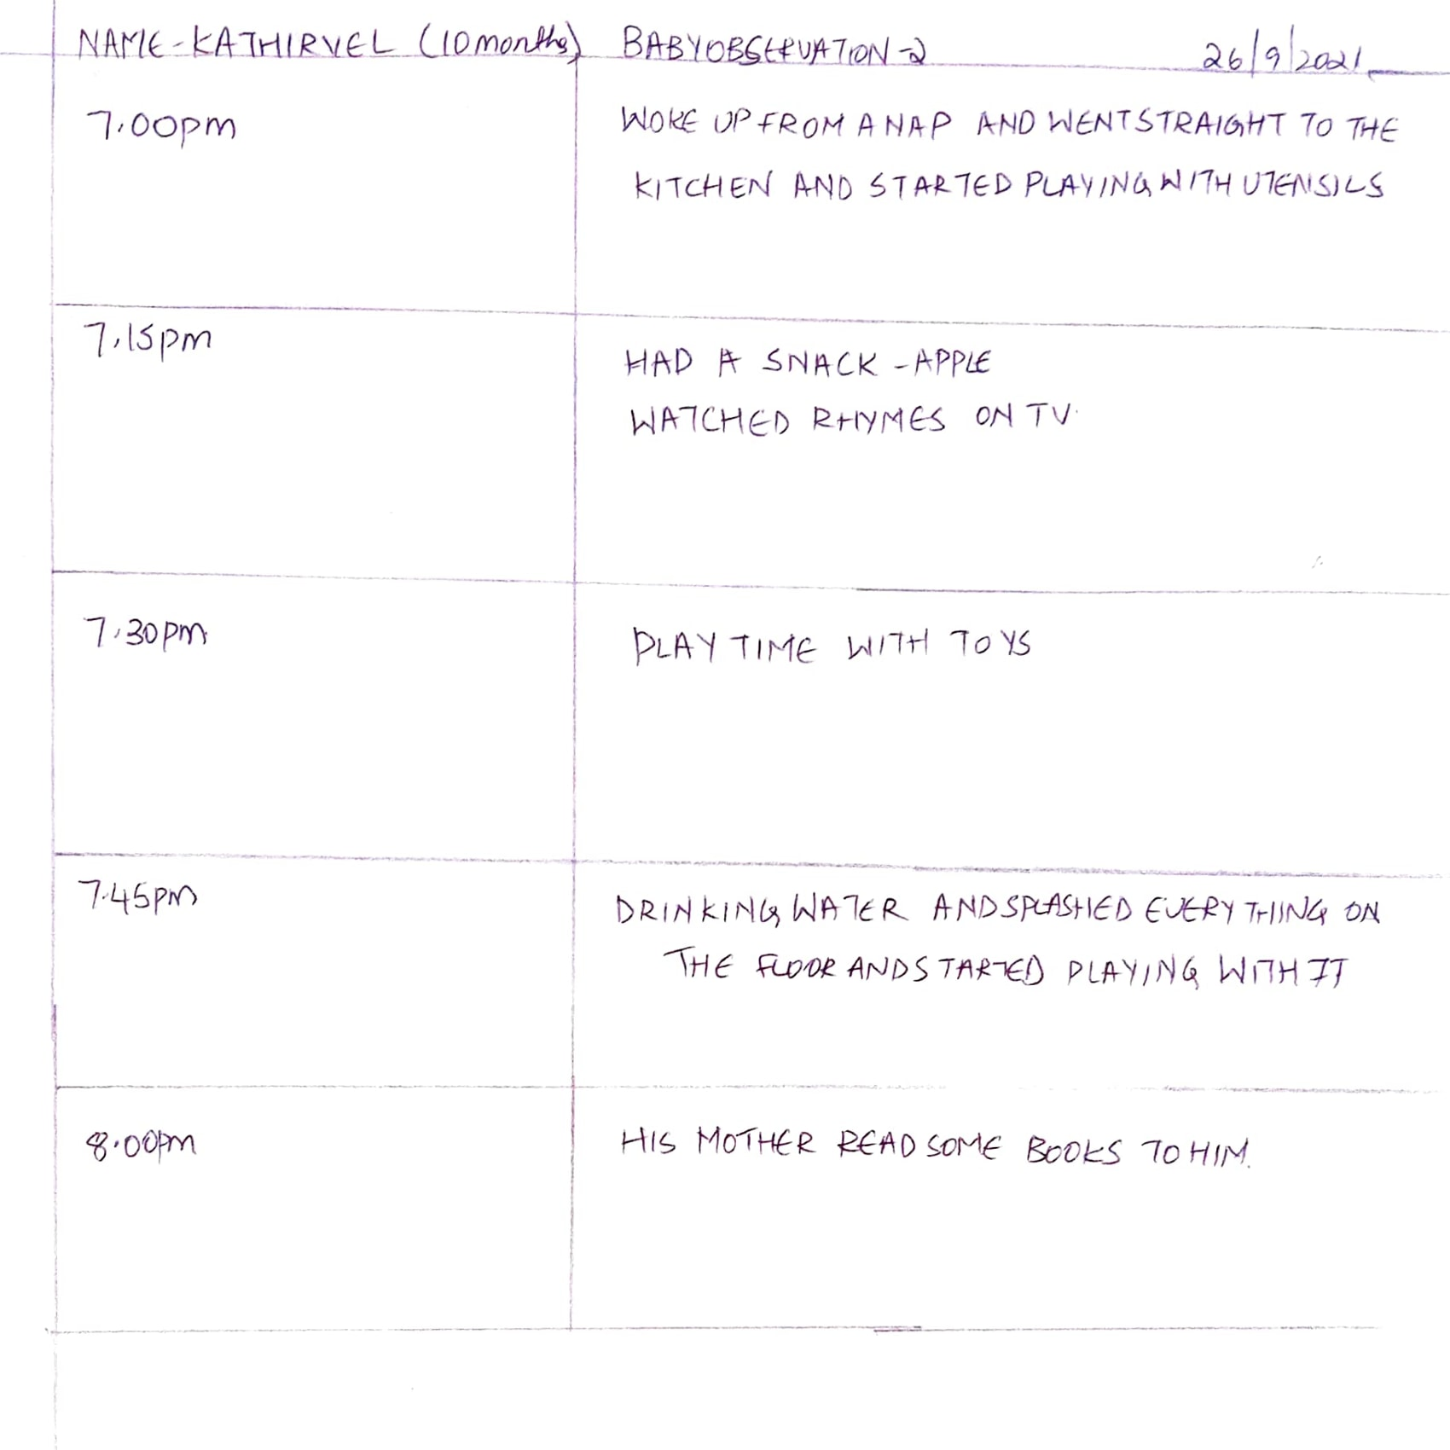

NAME OF THE BABY: Kathirvel

AGE: 10 months

HEIGHT: not known

WEIGHT: 7kgs

EATING: South Indian staple food, fruits, vegetables

SLEEP: 3 naps during the day, sleeps at 10 pm and wakes up at 7 am

ROUTINE: Wake up, breakfast, playtime, rhyme time, nap, lunch, playtime, reading time, evening snack, rhyme time, playtime, dinner, play with dad, story time with mom, time for bed.

Language: He can say mamma, papa, and thatha

Movement: Crawls fast around the house, trying to hold on to the walls and furniture and cruises through, is making an attempt to stand up and trying to walk, loves to play with utensils and slipppers

INDEPENDENCE: plays independently, dependent on mother for everything.

SOCIAL BEHAVIOUR: happy when sees someone, tries to hold their hand and play with them

The overall experience was very interesting and informative